**The Rutland Hotel, (Sleepwell Hotels Ltd), Douglas, Isle of Man**

**Accessibility Statement**

**Location**

The Rutland Hotel is located on the Queens Promenade in Douglas and has a bus stop within 50m as well as a horse drawn tram stop . For a location map please refer to our website https://www.sleepwellhotels.com/rutland/

The Rutland Hotel is approximately a 25 minute walk from the main Sea terminal <https://www.steam-packet.com/> or a 5 minute car journey.

From the Isle of Mans Ronaldsway Airport we recommend either a local taxi approximately £25 each way, or the Isle of Man bus service which runs directly from outside the airport terminal into Central Douglas.

For buses from the Airport into Douglas Town Centre: Services 1, 2, 2A, 2C 11 & 12

IOM Airport to Central Douglas 28 minute’s travel time   
IOM Airport to Douglas promenade 35 minute’s travel time

Please check Taxi / Bus availability and accessibility with the service provider directly.

Isle of Man Transport: Tel: 01624 662525 / www.iombusandrail.im

Telecabs: Tel: 01624 663344 / www.telecabs.com

**Wheelchairs and Wheelchair Access**

Unfortunately, we are unable to accommodate full time wheelchair users.

The hotel premises is set back from the sea facing promenade to a raised perspective and the retained original Victorian design and architecture features nine external steps from the pavement to the main entrance and the main hotel doorway access. The steps and the entrance are both tiled.

Internally all guest bedrooms are located on upper floors which also feature a number of internal steps at various locations around the corridor routes to access bedrooms due to the Victorian architecture of the building

Historically, the current hotel is formed of what was originally 3 separate properties joined together over time, each of which featured varying floor heights in some areas.

**Image of the Rutland Hotel guest entrance and external access**

**steps:**

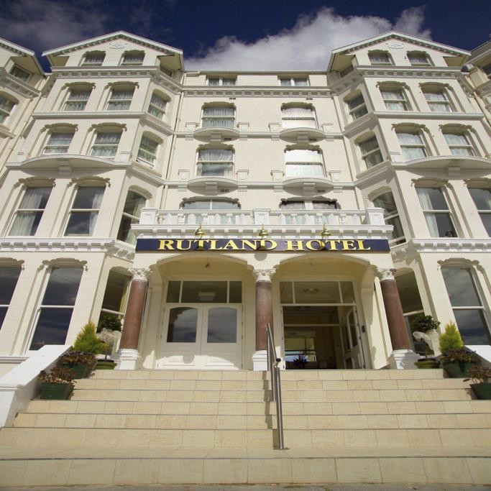

**Car Parking**

The hotel does not have a car park however unrestricted car parking is possible immediately outside the hotel on the public highway.

Reserving car parking spaces to the promenade highway is not possible.

**Hotel reception, guest lift and internal accessibility to reception, guest bedrooms, public areas, main restaurant and conference facilities.**

The external steps to enter the hotel has a central handrail to assist persons accessing the property, these steps are tiled. The hotel entrance has a maximum width of 1300mm

The hotel reception is accessed immediately upon entering the hotel to the ground floor.

The ground floor of the hotel incorporating the hotel reception, lift to guest bedrooms, public lounge areas, bar and hotel restaurant.

Public lavatories are accessible in the restaurant and bar on the ground floor. There are disabled toilets available in the bar and restaurant both of which have step free access and are fitted with emergency pull cords.

There is a lift to the hotel bedrooms set over 4 upper floors, with a door width of 680mm, depth of 775mm and a 320kg load capacity. Unfortunately our lift is not large enough to accommodate a wheelchair but on request, we are able to provide a chair to sit in and we will remove the self-closer from your door.

All floors have either a securely fixed carpet, tile or timber covering as appropriate to their use.

All areas are well lit with ceiling mounted lights using mainly low energy bulbs.

There is no fixed in-house ‘loop’ system. Any requirement for visual or hearing assistance should be discussed with us to see how we can help. Loop systems can be provided by the hotel for specific events on request.

**Bedrooms**

Unfortunately, the Hotel does not have any disabled access bedrooms and some public areas are not suitable to wheelchair users due to internal steps.

The Hotel is self-contained with 64 rooms of various sizes and lay outs. Floor plans for specific rooms can be provided on request.

Beds are of various sizes and heights. Details of any specific bed height as per room type booked can be provided on request.

A combination of ceiling, wall and table lamps are available. Additional lights can be supplied to guest bedrooms on request.

All decoration is primarily light-coloured paint finished walls with a mixture of light furnishings.

Rooms have varying brightness during the day subject to varying window apertures and whether the room has a sea facing location. Windows have blackout blinds and / or curtains fitted to ensure early morning light does not disturb.

Some of the furniture can be moved should it be required however some rooms have fixed beds, desks and other elements of joinery which cannot be removed.

All bedding is cotton. All pillows are anti allergenic hollow fibre.

Guest room TV’s have all available freeview channels with a standard domestic style remote control. No instructions, or audio descriptions are specifically available for this.

There is an telephone in each room, either to side table or desk and we do not charge for land line calls.

There is a hotel guide in each guest room with local contact numbers for hospitals, doctors etc. as well as a host of information about the Island and the hotel. The major (local) mobile network providers also have good signal strength.

Free high speed Wi-Fi is available in all rooms.

**Guest room bathrooms and lavatories**

All bedrooms are en-suite and in keeping with the various room designs have varying lay out and facilities.

Some rooms have ‘walk in showers’ some feature ‘step in’ baths with an overhead shower fitting or mixer tap feature.

Non- slip / rubber ‘bath-mats’ are available on request.

Lavatories and sinks are at standard heights as per domestic arrangements, additional details can be provided on request and subject to any specific room as may be booked.

Some rooms have handrails or supports to the guest room baths or showers, again details can be provided on request.

Lighting is supplied from central ceiling, shaver, and in some cases an integral shower cubicle light.

**Guest safety**

All guest bedrooms and public areas have heat / smoke detectors and fire alarm sounders to local fire certification requirements.

Guests requiring special assistance in the event of an evacuation are asked to inform the hotel on arrival. This information will be passed to local Fire and Rescue services upon their attendance.

Lifts should not be used in an emergency evacuation due to any potential power cut.

**Internal print, menus and other written information**

Hotel information, brochures or menus are not available in braille or audio form. We will, however, be pleased to assign members of staff to help guests with visual impairments who may need assistance.

**Dogs and Pets**

We do not accept pets, however we are pleased to accept assistance dogs at the hotel. Please inform us at the time of your booking so we can discuss these arrangements with you.

**Allergies**

Our professional catering team are fully equipped and trained to cater for guests with allergies. It is recommended that you inform us at the time of booking, so we can make arrangements to cater for your specific needs.

**Other information**

* Reception is manned 24 hours a day
* Porterage can by arranged by contacting reception
* Room service is available to any guests wishing to have meals in their rooms
* The hotel has no signs or literature in Braille

This accessibility statement is reviewed and updated on an ongoing basis to adhere to best practice and current health & safety legislation. We have tried to be as accurate as possible in our Access Statement but are always willing to give further information on any aspect of the hotel if you have a particular query. If you require further assistance, then please do not hesitate to contact us.

**Future Plans**

Sleepwell Hotels is committed to continuous ongoing improvement of our properties. Within the limitations of the building, planning and conservation area restrictions and we endeavour to incorporate more features to assist those with disabilities.

**Contact Information**

**Address:**

The Rutland Hotel

19-23 Palace Terrace   
Queens Promenade   
Douglas

Isle of Man   
IM2 4NF

**Telephone:**

(01624) 695240

**Email:**

rutland@sleepwellhotels.com

**Website:**

www.sleepwellhotels.com

**Hours Of Operation:**

24 Hours

**Local Accessible Taxi:**

24 Hours (pre-booked with reception)

**Additional Statement from Sleepwell Hotels Ltd**

We consider diversity and equality as the highest importance. We will not tolerate any discrimination in any form whatsoever against our guests, colleagues and employees, including, discrimination, harassment or victimisation.

We ask that all persons attending or considering attending our hotel please contact us to discuss any requests or individual requirements that we may be able to assist with and we will always endeavour to accommodate, where this may be possible.